**1. Describe the idea of WDS multicast transmission. Provide details and different configuration options.**

Windows Deployment Services enables you to deploy Windows operating systems. You can use it to set up new computers by using a network-based installation. This means that you do not have to install each operating system directly from installation media, for example a DVD or USB drive.

Windows Deployment Services provides the following benefits:

* Allows network-based installation of Windows operating systems, including Windows 7, Windows 8, Windows 8.1, Windows Server 2008 R2, Windows Server 2012, and Windows Server 2012 R2. It reduces the complexity and cost when compared to manual installations.
* Deploys Windows images to computers without operating systems.
* Supports mixed environments that include Windows Vista, Windows 7, Windows 8, Windows 8.1, Windows Server 2008 R2, Windows Server 2012, Windows Server 2012 R2, Windows XP, and Windows Server 2003.
* Uses standard Windows Server setup technologies, including Windows PE, .wim files, and image-based setup.

You can install Windows Deployment Services by using Server Manager, or using Windows PowerShell.

**Install using Server Manager**

1. In Server Manager, click Manage.
2. Click Add roles and features.
3. Select Role-based or feature-based installation and choose the server to deploy WDS.
4. On the Select server roles page select the Windows Deployment Services check box.
5. Click Next and follow the wizard to completion.

During installation, on the Select role services page, the wizard presents the option to select role services to be installed in Windows Deployment Services. You can choose to install the Deployment Server and Transport Server, or leave both roles selected.

* Transport Server. This option provides a subset of the functionality of Windows Deployment Services. It contains only the core networking parts. You can use Transport Server to create multicast namespaces that transmit data (including operating system images) from a standalone server. You can also use it if you want to have a PXE server that allows clients to PXE boot and download your own custom setup application. You should use this option if you want to use either of these scenarios , but you do not want to incorporate all of Windows Deployment Services.
* Deployment Server. This option provides the full functionality of Windows Deployment Services, which you can use to configure and remotely install Windows operating systems. Note that Deployment Server is dependent on the core parts of Transport Server.

**Using Windows PowerShell**

Do one of the following to open a Windows PowerShell session with elevated user rights.

* + On the Windows desktop, right-click Windows PowerShell on the taskbar, and then click Run as Administrator.
  + On the Windows Start page, type any part of the name Windows PowerShell. Right-click the shortcut for Windows PowerShell when it is displayed on theStart page in the Apps results, click Advanced, and then click Run as Administrator. To pin the Windows PowerShell shortcut to the Start page, right-click the shortcut, and then click Pin to Start.
* Type the following, and then press Enter, where *computer_name* represents a remote computer on which you want to install Hyper-V. To install WDS directly from a console session, do not include -ComputerName <computer_name> in the command.
* Install-WindowsFeature –Name WDS -ComputerName <computer_name> -IncludeManagementTools
* To view a list of available and installed roles and features on the local server, type Get-WindowsFeature and then press Enter. The results of the cmdlet contain the command names of roles and features that have been added to this computer.
* When the installation is finished, verify installation by running Get-WindowsFeature. If you installed WDS remotely, include the ComputerName parameter (Get-WindowsFeature –ComputerName <computer_name>) to view a list of roles and features that are installed on the server.

**Windows 7 : Using WDS for Multicast Deployments (part 2) - Creating a Multicast Deployment**

You now know some of the theory behind a WDS client. It is time to see how to put this theory to use. We will look at setting up the behavior of multicast on the WDS server. You can do this by editing options on the Multicast tab in the properties of the WDS server in the WDS console, shown in Figure 3.

Here you can configure how IPv4 or IPv6 addresses are assigned to WDS multicast clients. By default, the WDS server will manage a predefined range of IP addresses (select the Use Addresses From The Following Range radio button). You need to ensure that there is no IP range overlap between servers if more than one WDS server can service a subnet or subnets. You can choose to allow DHCP to manage the allocation of IP addresses (select the Obtain IP Address From DHCP radio button).

Figure 3. WDS server multicast configuration

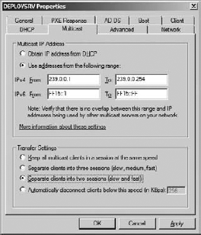

The Transfer Settings area allows you to manage how WDS multicast will deal with clients with different network connection speeds. You have four options here:

* The default, keep all clients in a single multicast session at the same speed
* Divide clients into slow, medium, and fast sessions
* Divide clients into slow and fast sessions
* Automatically disconnect WDS clients that have a connection speed that is less than defined (in Kbps)

You will choose one of the Transfer Settings options based on how many client network speeds you have and how many simultaneous streams you want. For example, if you have 100 Mbps and 1 Gbps clients, then will want to support slow and fast sessions. If you add additional clients with 10 Gbps network cards, you might want to support slow, medium, and fast sessions.

You need to create a multicast transmission in the WDS console (under Multicast Transmissions) and associate it with an installation image if you want to perform multicast deployments. Any WDS client requesting that installation image will then initiate or join a multicast session. You can create a multicast transmission by right-clicking and selecting Create Multicast Transmission.

The Create Multicast Transmission wizard will appear. The first screen asks you to name the transmission. Provide a meaningful name that will make sense to you and others at a later time.

The Image Selection screen allows you to associate an installation image with the multicast transmission. You can navigate between image groups and select the installation image that you want to deploy via multicast.

Figure 4 shows the Multicast Type screen. On this screen you can switch between the default Auto-Cast option (where the multicast starts as soon as any WDS client requests it) or the Scheduled-Cast option. The Scheduled-Cast option allows you to control the start of a multicast. In this way, you can make the most of multicast functionality and available bandwidth. By default, if you select Scheduled-Cast, WDS clients will join the multicast but nothing will happen until an administrator approves starts the session. There are two suboptions for Scheduled-Cast that allow the session to start automatically.

Start When The Number Of Clients That Have Requested The Image Is

This option allows an administrator to set a threshold. A minimum number of WDS clients must join the multicast before it starts.

Start At A Later Time

WDS administrators can define a date and time when the multicast session can start.

Figure 4. Configuring the multicast type

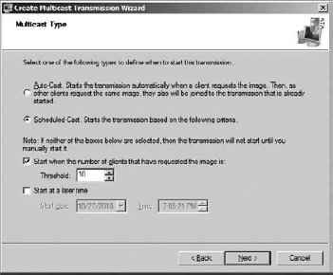

You can choose to not select any Scheduled-Cast suboptions, select one at a time, or combine them as required.

The new multicast transmission will appear in the WDS console under Multicast Transmissions. It will have a status of Waiting while no WDS clients are connected to it.

Note that you cannot edit the properties of a multicast transmission. You will have to delete it and re-create it if you want to make any changes. You can have more than one multicast transmission, thus providing support for different installation images.

Now you can boot up your WDS clients. Log into the WDS client and select the image that is associated with the new multicast transmission. If you selected the Scheduled-Cast option, the image download will not start right away. Instead, you will be told that the WDS client is waiting for the server, as shown in Figure 5.

Back in the WDS console, you can navigate into your new multicast transmission object to see which WDS clients are connected (you might need to refresh the screen). Here you have a few options. You can instruct a WDS client to bypass multicast and start a normal download. You can also disconnect the client to abort the image download.

You can right-click on a multicast transmission to manually start the session. You can do so even if the transmission has not yet met any defined start conditions.

Figure 5. A WDS client waiting for a scheduled multicast

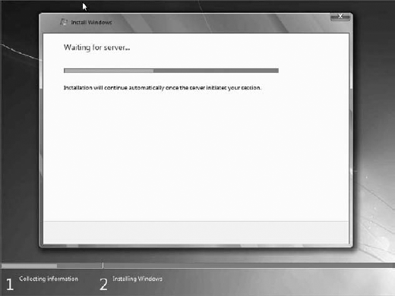

The multicast session will appear as Active once it starts. The detail for each WDS client's session can be seen within the multicast transmission object. Here you get information that can be used to monitor progress and troubleshoot the multicast transmission:

* Identifying information (MAC address and IP address)
* Image download progress (Status)
* The amount of time that the WDS client has been connected to the multicast transmission
* Data transfer rate
* WDS client CPU utilization

The image will be expanded and installed once it is downloaded to the clients.

4. Troubleshooting a Multicast Deployment

Two problems can commonly occur with a multicast deployment.

4.1. Slow Multicast Image Download

The most common complaint will be that a multicast transmission is very slow. You should use the multicast transmission client information in the WDS console. Doing so gives you a quick overview of what is happening.

The most obvious thing to do is to check the network. Things like dodgy switch ports or other network activity could affect the speed of an image download. Microsoft recommends that you use switches instead of hubs, and that you use CAT5 or CAT5e cabling or better. Check with your network administrator colleagues or the network monitoring systems to see if anything stands out.

You may have a mix of clients with different connection speeds. If so, make sure that you have set up the multicast configuration (WDS server properties) to divide up the transmission into slow/fast or slow/medium/fast sessions.

Sometimes a single faulty machine can cause a large multicast to run slowly. This machine will have a slow connection and will become the master client, thus reducing the download for everyone else in its session. You can identify the master client by running this command:

Wdsutil /Get-AllMulticastTransmissions /ShowiInstall /DetailsiClients

This code will return information on each of the clients. Search for an attribute called Master Client where the value is set to Yes. This is the machine that is causing the session to be slow. Note the ClientID value for this machine. This value is what you will use to identify the machine. You can disconnect this machine in the console or by running this command:

Wdsutil /Disconnect-Client /ClientID:<ClientID of the master client>

The role of master client will switch to the next slowest machine. Check the download rates to see if they have improved. If not, you will need to identify and disconnect the new master client.

4.2. Network Flooding with IGMP Snooping Disabled

Without IGMP snooping enabled on network devices, the multicast will effectively become a broadcast and can flood the network. The obvious answer would be to enable IGMP snooping. This might not be possible. If that is the case, you can limit the life of the multicast packets on the network using a Registry edit on the WDS server. Microsoft suggests that you set the time-to-live (TTL) for the multicast packets to 32. On Windows Server 2008 you do so by editing HKEY_ LOCAL_MACHINE\SYSTEM\CurrentControlSet\Services\WDSServer\Providers\Multicast\ Profiles. On Windows Server 2008 R2, you do so by editing HKEY_LOCAL_MACHINE\System\ CurrentControlSet\Services\WDSServer\Providers\WDSMC\Protocol.

<http://programming4.us/desktop/21748.aspx>

<http://technet.microsoft.com/en-us/library/jj648426.aspx#WDS_WhatisWindowsDeploymentServices>

http://blog.augustoalvarez.com.ar/2008/12/12/installing-and-configuring-wds-windows-deployment-services-full-images-deployment-part-i/